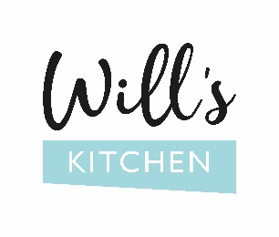

CHILDREN’S MENU

All at £6.50

Buttermilk pancakes, cherry compote 

Mini beef sliders, cheddar & skin on potato fries

Penne pasta, tomato sauce & grated cheese 

Ham & cheese toastie,

skin on fries

All children’s meals come with a

Pip organic fruity water